Frederick Kelemen

2715308

10/09/2021

CIS 496 Project 3

This project is available at http://cis.csuhio.edu/~frkeleme

Follow links under Project 3. The project won't work correctly if you use the eecs site instead of the cis site.

Images:

Figure 1: Empty Screen, No Tabs Clicked

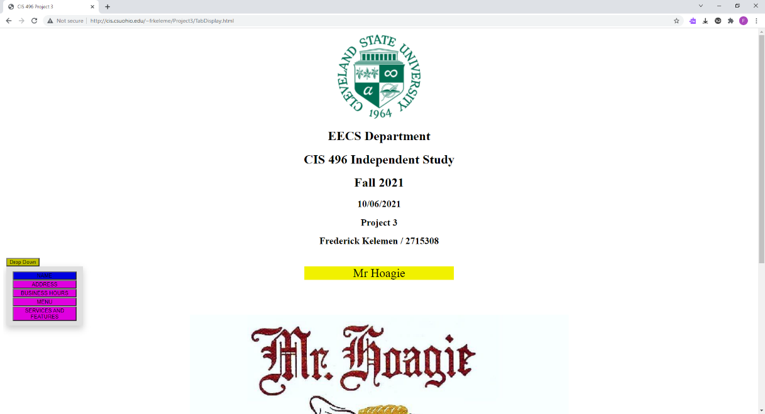

Figure 2: Screen Displaying Only the Name

Figure 3: Screen Displaying the Name and Address

Figure 4: Screen Displaying Name, Address, and Hours

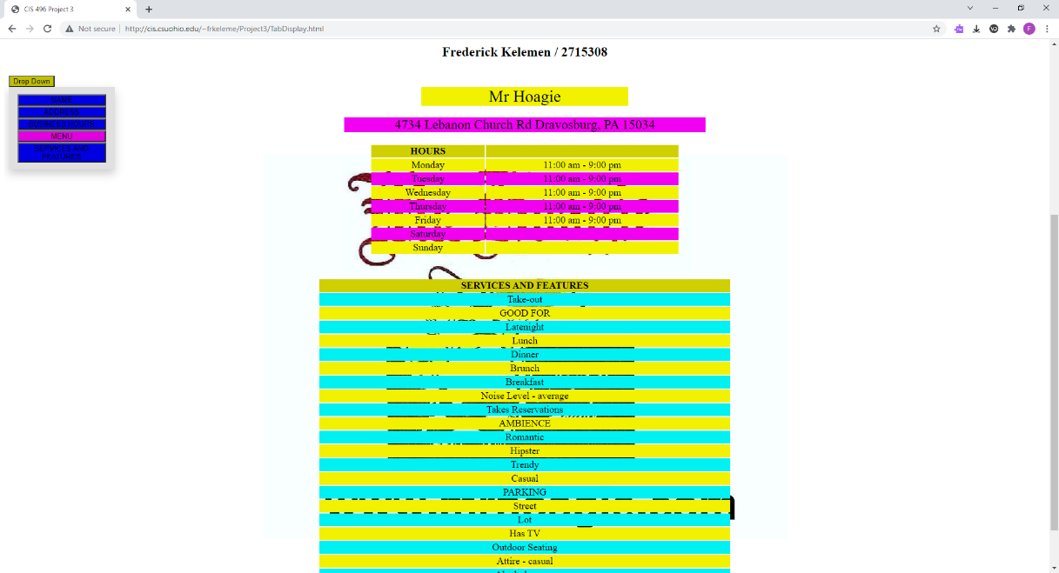

Figure 5: Screen Displaying Name, Address, Hours, and Services

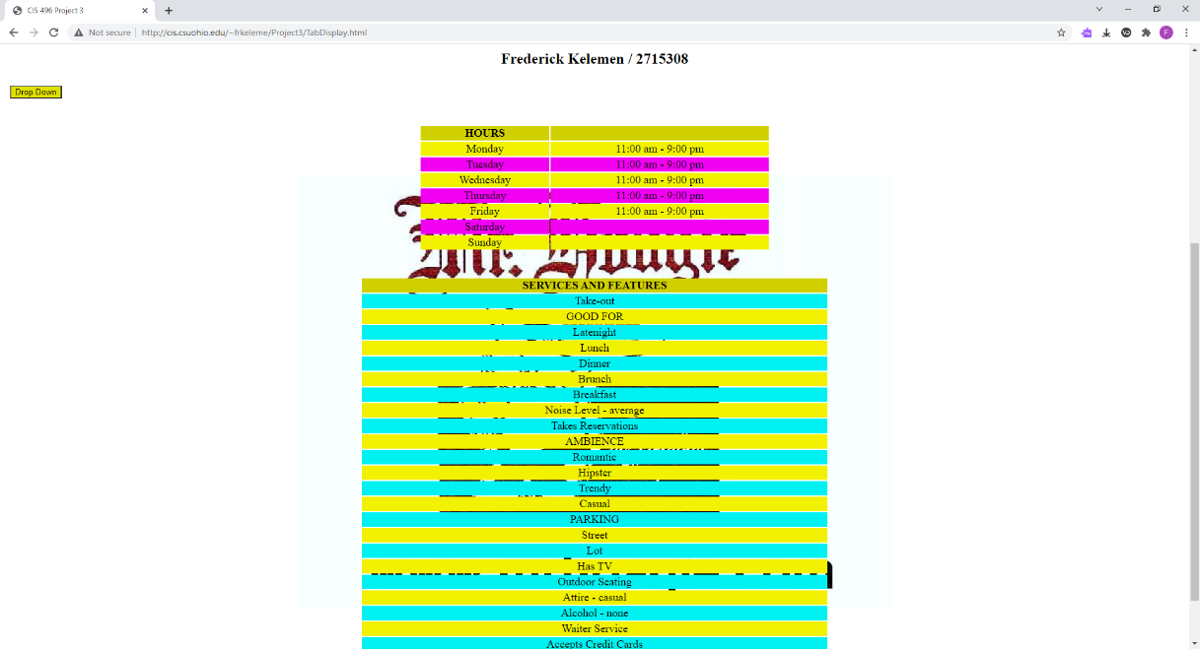

Figure 6: Screen Displaying Hours and Services

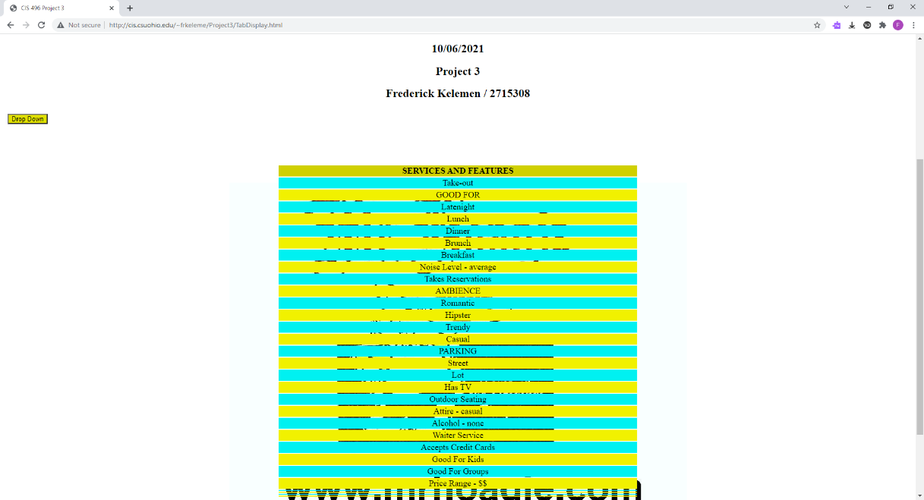

Figure 7: Screen Displaying Only Services

**p1.html**

<!DOCTYPE html>

<html lang="en" class="proj2">

<head>

<meta charset="utf-8">

<title>CIS 496 Project 2 Problem 1</title>

<link rel="stylesheet" href="TabDisplay.css">

<script src="projFunctions.js"></script>

<div class="dropdown"><button class="tabBtn1">Drop Down</button>

<div class="dropdown-content">

<button type="button" class="tabBtn2" onclick="tabFunc(event, 'name')">NAME</button>

<button type="button" class="tabBtn2" onclick="tabFunc(event, 'address')">ADDRESS</button>

<button type="button" class="tabBtn2" onclick="tabFunc(event, 'hours')">BUSINESS HOURS</button>

<button type="button" class="tabBtn2" onclick="tabFunc(event, 'menu')">MENU</button>

<button type="button" class="tabBtn2" onclick="tabFunc(event, 'services')">SERVICES AND FEATURES</button>

</div>

</div>

</head>

<body>

<center>

<div class="page">

<div class="name" id="name"></div>

<br>

<div class="address" id="address"></div>

<br>

<div class="hours" id="hours">

<table class="tableHours">

<tr class="tHead1">

<th>HOURS</th>

<th></th>

</tr>

<tr class="tRow1">

<td class="cRow1">Monday</td>

<td class="cRow1" id="mondayHrs"></td>

</tr>

<tr class="tRow2">

<td class="cRow1">Tuesday</td>

<td class="cRow1" id="tuesdayHrs"></td>

</tr>

<tr class="tRow1">

<td class="cRow1">Wednesday</td>

<td class="cRow1" id="wednesdayHrs"></td>

</tr>

<tr class="tRow2">

<td class="cRow1">Thursday</td>

<td class="cRow1" id="thursdayHrs"></td>

</tr>

<tr class="tRow1">

<td class="cRow1">Friday</td>

<td class="cRow1" id="fridayHrs"></td>

</tr>

<tr class="tRow2">

<td class="cRow1">Saturday</td>

<td class="cRow1" id="saturdayHrs"></td>

</tr>

<tr class="tRow1">

<td class="cRow1">Sunday</td>

<td class="cRow1" id="sundayHrs"></td>

</tr>

</table>

</div>

<br>

<div class="menu" id="menu"></div>

<br>

<div class="services" id="services">

<table class="tableServices">

<tr class="tHead1">

<th class="cHead2">SERVICES AND FEATURES</th>

</tr>

<tr class="tRow3">

<td class="cRow2" id="serv1"></td>

</tr>

<tr class="tRow4">

<td class="cRow2" id="serv2"></td>

</tr>

<tr class="tRow3">

<td class="cRow2" id="serv3"></td>

</tr>

<tr class="tRow4">

<td class="cRow2" id="serv4"></td>

</tr>

<tr class="tRow3">

<td class="cRow2" id="serv5"></td>

</tr>

<tr class="tRow4">

<td class="cRow2" id="serv6"></td>

</tr>

<tr class="tRow3">

<td class="cRow2" id="serv7"></td>

</tr>

<tr class="tRow4">

<td class="cRow2" id="serv8"></td>

</tr>

<tr class="tRow3">

<td class="cRow2" id="serv9"></td>

</tr>

<tr class="tRow4">

<td class="cRow2" id="serv10"></td>

</tr>

<tr class="tRow3">

<td class="cRow2" id="serv11"></td>

</tr>

<tr class="tRow4">

<td class="cRow2" id="serv12"></td>

</tr>

<tr class="tRow3">

<td class="cRow2" id="serv13"></td>

</tr>

<tr class="tRow4">

<td class="cRow2" id="serv14"></td>

</tr>

<tr class="tRow3">

<td class="cRow2" id="serv15"></td>

</tr>

<tr class="tRow4">

<td class="cRow2" id="serv16"></td>

</tr>

<tr class="tRow3">

<td class="cRow2" id="serv17"></td>

</tr>

<tr class="tRow4">

<td class="cRow2" id="serv18"></td>

</tr>

<tr class="tRow3">

<td class="cRow2" id="serv19"></td>

</tr>

<tr class="tRow4">

<td class="cRow2" id="serv20"></td>

</tr>

<tr class="tRow3">

<td class="cRow2" id="serv21"></td>

</tr>

<tr class="tRow4">

<td class="cRow2" id="serv22"></td>

</tr>

<tr class="tRow3">

<td class="cRow2" id="serv23"></td>

</tr>

<tr class="tRow4">

<td class="cRow2" id="serv24"></td>

</tr>

<tr class="tRow3">

<td class="cRow2" id="serv25"></td>

</tr>

<tr class="tRow4">

<td class="cRow2" id="serv26"></td>

</tr>

<tr class="tRow3">

<td class="cRow2" id="serv27"></td>

</tr>

<tr class="tRow4">

<td class="cRow2" id="serv28"></td>

</tr>

<tr class="tRow3">

<td class="cRow2" id="serv29"></td>

</tr>

<tr class="tRow4">

<td class="cRow2" id="serv30"></td>

</tr>

</table>

</div>

<br>

<script>siteStart();</script>

</div>

</center>

</body>

</html>

**TabDisplay.html**

<!DOCTYPE html>

<html lang="en" class="proj3">

<head>

<title>CIS 496 Project 3</title>

<center><p><img src="CSU_Logo.jpg"width="11%"height="20%">

<p><h1>EECS Department</h1>

<p><h1>CIS 496 Independent Study</h1>

<p><h1>Fall 2021</h1>

<p><h2>10/06/2021</h2>

<p><h2>Project 3</h2>

<p><h2>Frederick Kelemen / 2715308</h2></center>

<link rel="stylesheet" href="TabDisplay.css">

<script src="projFunctions.js"></script>

</head>

<body>

<iframe scrolling="no" seamless="seamless" id="tabDisplayFrame" src="p1.html" class=frame1 title="Home"></iframe>

</body>

</html>

**TabDisplay.css**

.proj2 {

font-size: 18px;

font-family: TimesNewRoman;

}

.tabBtn1 {

width: 100%;

background-color: #e0e000;

}

.tabBtn2 {

width: 100%;

background-color: #e000e0;

}

.active {

background-color: #0000e0;

}

.dropdown {

position: relative;

display: inline-block;

}

.dropdown-content {

display: none;

position: absolute;

background-color:#e0e0e0;

min-width: 160px;

box-shadow: 0px 8px 16px 0px rgba(0,0,0,0.2);

padding: 12px 16px;

z-index: 1;

}

.dropdown:hover .dropdown-content {

display: block;

}

.tabBtn1:hover {

background-color: #c0c000;

}

.tabBtn2:hover {

background-color: #b000b0;

}

.bodyP2 {

display: inline-block;

width: 100%;

height: 100%;

}

.frame1 {

width: 100%;

height: 1000px;

border: none;

background-image: url('Mr_Hoagie_Logo.jpg');

background-repeat: no-repeat;

background-position: center;

}

.frame2 {

width: 45%;

height: 900px;

margin: 10px;

}

.slideShow {

display: inline-block;

height: 300px;

width: 600px;

vertical-align: top;

overflow: visible;

}

.imgButton {

width: 30px;

height: 100%;

border: none;

margin: 2px 2px 1px 1px;

background-color: white;

vertical-align: top;

}

.img1 {

height: 100%;

vertical-align: top;

}

.img2 {

width: 25px;

height: 25px;

vertical-align: center;

}

.header1 {

text-align: left;

margin-left: 20px;

font-size: 25px;

font-style: bold;

}

.list1 {

text-align: left;

margin-left: 30px;

font-size: 18px;

text-decoration: none;

}

.video1 {

vertical-align: top;

width: 75%;

height: auto;

margin: 30px;

}

.vidBtn {

width: 200px;

height: 40px;

opacity: 0;

}

.vidBtn:hover {

opacity: 1;

}

.canvas1 {

width: 100%;

height: 150px;

}

.address {

display: none;

font-size: 24px;

background-color: #f100f1;

width: 35%;

}

.tableHours {

width: 30%;

}

.tableServices {

width: 40%;

}

.hours {

width: 100%;

display: none;

}

.services {

width: 100%;

display: none;

}

.name {

width: 20%;

display: none;

font-size: 30px;

background-color: #f1f100;

}

.tHead1 {

width: 100%;

text-align: center;

background-color: #d0d000;

}

.tRow1 {

background-color: #f1f100;

text-align: center;

}

.tRow2 {

background-color: #f100f1;

text-align: center;

}

.tRow3 {

background-color: #00f1f1;

text-align: center;

visibility: hidden;

}

.tRow4 {

background-color: #f1f100;

text-align: center;

visibility: hidden;

}

**projFunctions.js**

var imgCount = 1;

var plypse = 0;

var started = 0;

function loadDoc() {

const xhttp = new XMLHttpRequest();

xhttp.open("GET", "http://cis.csuohio.edu/~sschung/CIS408/YelpOneBusinessJsonData.json", false);

xhttp.send();

text1 = xhttp.responseText;

return text1;

}

function siteStart() {

text1 = loadDoc();

text1 = text1.replace('\n',' ');

const obj = JSON.parse(text1);

document.getElementById('name').innerHTML = obj.name;

document.getElementById('address').innerHTML = obj.full_address;

document.getElementById('mondayHrs').innerHTML = calcHours(obj.hours.Monday['open']) + ' - ' + calcHours(obj.hours.Monday['close']);

document.getElementById('tuesdayHrs').innerHTML = calcHours(obj.hours.Tuesday['open']) + ' - ' + calcHours(obj.hours.Tuesday['close']);

document.getElementById('wednesdayHrs').innerHTML = calcHours(obj.hours.Wednesday['open']) + ' - ' + calcHours(obj.hours.Wednesday['close']);

document.getElementById('thursdayHrs').innerHTML = calcHours(obj.hours.Thursday['open']) + ' - ' + calcHours(obj.hours.Thursday['close']);

document.getElementById('fridayHrs').innerHTML = calcHours(obj.hours.Friday['open']) + ' - ' + calcHours(obj.hours.Friday['close']);

if (obj.hours.Saturday != undefined) {

document.getElementById('saturdayHrs').innerHTML = calcHours(obj.hours.Saturday['open']) + ' - ' + calcHours(obj.hours.Saturday['close']);

}

if (obj.hours.Sunday != undefined) {

document.getElementById('sundayHrs').innerHTML = calcHours(obj.hours.Sunday['open']) + ' - ' + calcHours(obj.hours.Sunday['close']);

}

var i = 1;

if (obj.attributes['Take-out'] == true) {

document.getElementById('serv'+i).innerHTML = 'Take-out';

document.getElementById('serv'+i).style.visibility = 'visible';

i++;

}

if (obj.attributes['Drive-Thru'] == true) {

document.getElementById('serv'+i).innerHTML = 'Drive-Thru';

document.getElementById('serv'+i).style.visibility = 'visible';

i++;

}

document.getElementById('serv'+i).innerHTML = 'GOOD FOR';

document.getElementById('serv'+i).style.visibility = 'visible';

i++;

if (obj.attributes['Good For']['dessert'] == true) {

document.getElementById('serv'+i).innerHTML = 'Dessert';

document.getElementById('serv'+i).style.visibility = 'visible';

i++;

}

if (obj.attributes['Good For']['latenight'] == true) {

document.getElementById('serv'+i).innerHTML = 'Latenight';

document.getElementById('serv'+i).style.visibility = 'visible';

i++;

}

if (obj.attributes['Good For']['lunch'] == true) {

document.getElementById('serv'+i).innerHTML = 'Lunch';

document.getElementById('serv'+i).style.visibility = 'visible';

i++;

}

if (obj.attributes['Good For']['dinner'] == true) {

document.getElementById('serv'+i).innerHTML = 'Dinner';

document.getElementById('serv'+i).style.visibility = 'visible';

i++;

}

if (obj.attributes['Good For']['brunch'] == true) {

document.getElementById('serv'+i).innerHTML = 'Brunch';

document.getElementById('serv'+i).style.visibility = 'visible';

i++;

}

if (obj.attributes['Good For']['breakfast'] == true) {

document.getElementById('serv'+i).innerHTML = 'Breakfast';

document.getElementById('serv'+i).style.visibility = 'visible';

i++;

}

if (obj.attributes['Caters'] == true) {

document.getElementById('serv'+i).innerHTML = 'Caters';

document.getElementById('serv'+i).style.visibility = 'visible';

i++;

}

document.getElementById('serv'+i).innerHTML = 'Noise Level - ' + obj.attributes['Noise Level'];

document.getElementById('serv'+i).style.visibility = 'visible';

i++;

if (obj.attributes['Takes Reservations'] == true) {

document.getElementById('serv'+i).innerHTML = 'Takes Reservations';

document.getElementById('serv'+i).style.visibility = 'visible';

i++;

}

if (obj.attributes['Delivery'] == true) {

document.getElementById('serv'+i).innerHTML = 'Delivery';

document.getElementById('serv'+i).style.visibility = 'visible';

i++;

}

document.getElementById('serv'+i).innerHTML = 'AMBIENCE';

document.getElementById('serv'+i).style.visibility = 'visible';

i++;

if (obj.attributes.Ambience['romantic'] == true) {

document.getElementById('serv'+i).innerHTML = 'Romantic';

document.getElementById('serv'+i).style.visibility = 'visible';

i++;

}

if (obj.attributes.Ambience['intimate'] == true) {

document.getElementById('serv'+i).innerHTML = 'Intimate';

document.getElementById('serv'+i).style.visibility = 'visible';

i++;

}

if (obj.attributes.Ambience['classy'] == true) {

document.getElementById('serv'+i).innerHTML = 'Classy';

document.getElementById('serv'+i).style.visibility = 'visible';

i++;

}

if (obj.attributes.Ambience['hipster'] == true) {

document.getElementById('serv'+i).innerHTML = 'Hipster';

document.getElementById('serv'+i).style.visibility = 'visible';

i++;

}

if (obj.attributes.Ambience['divey'] == true) {

document.getElementById('serv'+i).innerHTML = 'Divey';

document.getElementById('serv'+i).style.visibility = 'visible';

i++;

}

if (obj.attributes.Ambience['touristy'] == true) {

document.getElementById('serv'+i).innerHTML = 'Touristy';

document.getElementById('serv'+i).style.visibility = 'visible';

i++;

}

if (obj.attributes.Ambience['trendy'] == true) {

document.getElementById('serv'+i).innerHTML = 'Trendy';

document.getElementById('serv'+i).style.visibility = 'visible';

i++;

}

if (obj.attributes.Ambience['upscale'] == true) {

document.getElementById('serv'+i).innerHTML = 'Upscale';

document.getElementById('serv'+i).style.visibility = 'visible';

i++;

}

if (obj.attributes.Ambience['casual'] == true) {

document.getElementById('serv'+i).innerHTML = 'Casual';

document.getElementById('serv'+i).style.visibility = 'visible';

i++;

}

document.getElementById('serv'+i).innerHTML = 'PARKING';

document.getElementById('serv'+i).style.visibility = 'visible';

i++;

if (obj.attributes.Parking['garage'] == true) {

document.getElementById('serv'+i).innerHTML = 'Garage';

document.getElementById('serv'+i).style.visibility = 'visible';

i++;

}

if (obj.attributes.Parking['street'] == true) {

document.getElementById('serv'+i).innerHTML = 'Street';

document.getElementById('serv'+i).style.visibility = 'visible';

i++;

}

if (obj.attributes.Parking['validated'] == true) {

document.getElementById('serv'+i).innerHTML = 'Validated';

document.getElementById('serv'+i).style.visibility = 'visible';

i++;

}

if (obj.attributes.Parking['lot'] == true) {

document.getElementById('serv'+i).innerHTML = 'Lot';

document.getElementById('serv'+i).style.visibility = 'visible';

i++;

}

if (obj.attributes.Parking['valet'] == true) {

document.getElementById('serv'+i).innerHTML = 'Valet';

document.getElementById('serv'+i).style.visibility = 'visible';

i++;

}

if (obj.attributes['Has TV'] == true) {

document.getElementById('serv'+i).innerHTML = 'Has TV';

document.getElementById('serv'+i).style.visibility = 'visible';

i++;

}

if (obj.attributes['Outdoor Seating'] == true) {

document.getElementById('serv'+i).innerHTML = 'Outdoor Seating';

document.getElementById('serv'+i).style.visibility = 'visible';

i++;

}

document.getElementById('serv'+i).innerHTML = 'Attire - ' + obj.attributes['Attire'];

document.getElementById('serv'+i).style.visibility = 'visible';

i++;

document.getElementById('serv'+i).innerHTML = 'Alcohol - ' + obj.attributes['Alcohol'];

document.getElementById('serv'+i).style.visibility = 'visible';

i++;

if (obj.attributes['Waiter Service'] == true) {

document.getElementById('serv'+i).innerHTML = 'Waiter Service';

document.getElementById('serv'+i).style.visibility = 'visible';

i++;

}

if (obj.attributes['Accepts Credit Cards'] == true) {

document.getElementById('serv'+i).innerHTML = 'Accepts Credit Cards';

document.getElementById('serv'+i).style.visibility = 'visible';

i++;

}

if (obj.attributes['Good for Kids'] == true) {

document.getElementById('serv'+i).innerHTML = 'Good For Kids';

document.getElementById('serv'+i).style.visibility = 'visible';

i++;

}

if (obj.attributes['Good For Groups'] == true) {

document.getElementById('serv'+i).innerHTML = 'Good For Groups';

document.getElementById('serv'+i).style.visibility = 'visible';

i++;

}

document.getElementById('serv'+i).innerHTML = 'Price Range - ' + parsePrice(obj.attributes['Price Range']);

document.getElementById('serv'+i).style.visibility = 'visible';

i++;

}

function tabFunc(evt, tab) {

switch(tab) {

case 'name':

if (!evt.currentTarget.className.includes('active')) {

document.getElementById('name').style.display = "block";

} else {

document.getElementById('name').style.display = "none";

}

break;

case 'address':

if (!evt.currentTarget.className.includes('active')) {

document.getElementById('address').style.display = "block";

} else {

document.getElementById('address').style.display = "none";

}

break;

case 'hours':

if (!evt.currentTarget.className.includes('active')) {

document.getElementById('hours').style.display = "block";

} else {

document.getElementById('hours').style.display = "none";

}

break;

case 'menu':

if (!evt.currentTarget.className.includes('active')) {

document.getElementById('menu').style.display = "block";

} else {

document.getElementById('menu').style.display = "none";

}

break;

case 'services':

if (!evt.currentTarget.className.includes('active')) {

document.getElementById('services').style.display = "block";

} else {

document.getElementById('services').style.display = "none";

}

break;

}

var tabBtn = document.getElementsByClassName('tabButton');

if (evt.currentTarget.className.includes('active')) {

evt.currentTarget.className = evt.currentTarget.className.replace(' active', '');

} else {

evt.currentTarget.className += ' active';

}

}

function calcHours(time) {

var time2 = time.substring(0,2);

var time3 = time.substring(2);

var ampm = '';

switch(time2) {

case '12':

ampm = 'pm'

break;

case '13':

time2 = '1';

ampm = 'pm';

break;

case '14':

time2 = '2';

ampm = 'pm';

break;

case '15':

time2 = '3';

ampm = 'pm';

break;

case '16':

time2 = '4';

ampm = 'pm';

break;

case '17':

time2 = '5';

ampm = 'pm';

break;

case '18':

time2 = '6';

ampm = 'pm';

break;

case '19':

time2 = '7';

ampm = 'pm';

break;

case '20':

time2 = '8';

ampm = 'pm';

break;

case '21':

time2 = '9';

ampm = 'pm';

break;

case '22':

time2 = '10';

ampm = 'pm';

break;

case '23':

time2 = '11';

ampm = 'pm';

break;

case '24':

time2 = '12';

ampm = 'am';

break;

default:

ampm = 'am';

break;

}

time = time2 + time3 + ' ' + ampm;

return time;

}

function parsePrice(price) {

switch(price) {

case 1:

price = '$';

break;

case 2:

price = '$$';

break;

case 3:

price = '$$$';

break;

case 4:

price = '$$$$';

break;

}

return price;

}

function imgFunc(i) {

if (i == 2 && imgCount < 3) {

imgCount++;

} else if (i == 2 && imgCount == 3) {

imgCount = 1;

} else if (i == 1 && imgCount > 1) {

imgCount--;

} else if (i == 1 && imgCount == 1) {

imgCount = 3;

}

document.getElementById('img1').src="pic"+imgCount+".jpg";

}

function vidFunc(evt, i) {

if (i == 1 && plypse == 0 && started == 0) {

plypse = 1;

started = 1;

document.getElementById('vidBtn1').innerHTML = '||';

document.getElementById('vid1').play();

vidStart();

} else if (i == 1 && plypse == 0) {

plypse = 1;

document.getElementById('vidBtn1').innerHTML = '||';

document.getElementById('vid1').play();

} else if (i == 1 && plypse == 1) {

plypse = 0;

document.getElementById('vidBtn1').innerHTML = '>';

document.getElementById('vid1').pause();

} else if (i == 2) {

document.getElementById('vid1').currentTime = 0;

} else if (i == 3) {

document.getElementById('vid1').currentTime -= 10;

} else if (i == 4) {

document.getElementById('vid1').currentTime += 10

}

}

function vidStart() {

setInterval(function vidFunc2() {

var vid = document.getElementById('vid1');

var curTime = vid.currentTime.toFixed(0);

var vidTime = (curTime/3600).toFixed(0) + ':' + ((curTime%3600)/60).toFixed(0) + ':' + (curTime%60).toFixed(0);

var dur = vid.duration.toFixed(0);

var vidDur = (dur/3600).toFixed(0) + ':' + ((dur%3600)/60).toFixed(0) + ':' + (dur%60).toFixed(0);

document.getElementById('vidTime').innerHTML = vidTime;

document.getElementById('vidDuration').innerHTML = vidDur;

}, 500)

}

function myFunction() {

var x = document.getElementById("form1").action;

document.getElementById("demo").innerHTML = x;

}

function formFunc1() {

var fname = document.getElementsByName('fName')[0].value;

var lname = document.getElementsByName('lName')[0].value;

var email = document.getElementsByName('email')[0].value;

var action = document.getElementById('form1').action;

var string = 'fname: ' + fname + '<br> lname: ' + lname + '<br> email: ' + email + '<br>' + action;

document.getElementById('list2').innerHTML = string;

}

function animate() {

x += 1;

myContext.clearRect(0, 0, myCanvas.width, myCanvas.height);

myContext.drawImage(img, x, 0, 145, 145);

window.requestAnimationFrame(animate);

if (x == myCanvas.width)

x = 0;

}